**Project Summary:**

Overall, this project turned out to be much more of a task than we initially expected. Although we were able to fulfill our system requirements, we did end up having to change a few things as we built the program. Our original Database entity relationship diagram is miles away from the one we ended up with, as we had to alter and add many tables. We will Add a comparison of the two at the end of this document. In the end we also made it so students self-enrolled in classes and programs, instead of the administrator doing it for them. Students can drop and enroll in individual classes from separate programs as well, also on their own. Students are only able to do this after and administrator approves their registration, as per the system requirements.

For comparison here is the original diagram:

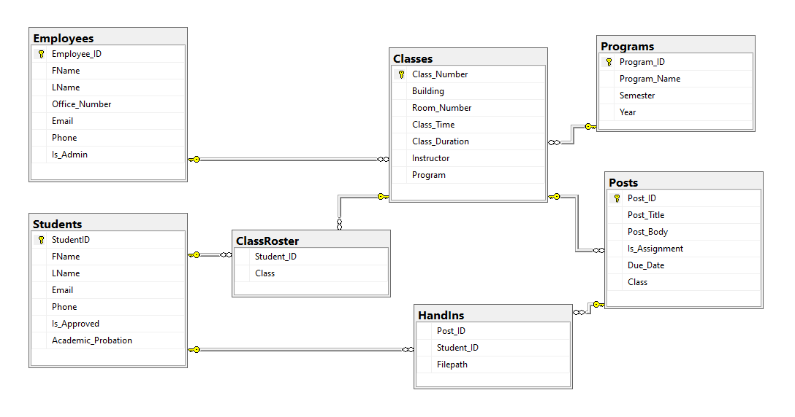And here is the final one:

